**RGB to RED:**

The RGB image I’ve chosen is the art photo seen below:

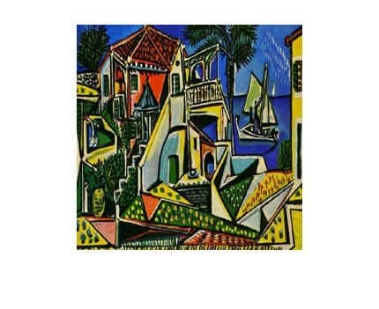

Figure01: The chosen RGB image file (pablo.jpg)

A R, G, B component is represented by default 8 bit unsigned data type. 8-bit representation gives a scale of 0 to 255, with 0 being the darkest and 255 the brightness in the particular color component.

After extracting the Red, Blue and Green component we find the following figure-

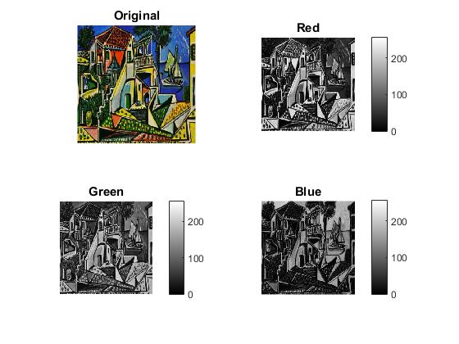

Figure02: Each Red, Green and Blue intensity in the Original image

From the above figure we can deduce that the Red component is found in lots of places in the image. Those places have values around 200-255 and seen as lighter than other places in the image. Mostly the lighter places are the color Red, Orange and Yellow.

**RGB to Grayscale:**

The same image is converted to the grayscale image.

The outcome is shown below-

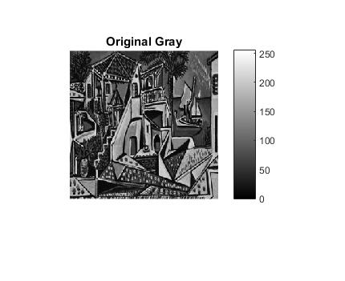

Figure03: Grayscale image of the Original image.

The grayscale image gives multiple shades of grays (combination of black and white) based on the image intensity or brightness of the image.

**Grayscale Histogram:**

Grayscale histogram shows for each grayscale shades how many pixels having that shade.

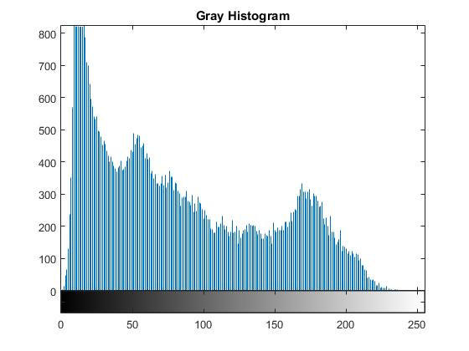

Figure04: Histogram of grayscale image of the original image.

From the histogram we can say that lighter pixels are less in number than the darker pixels.

**Negative film/ Flipping the shades:**

Changing the dark to bright shade gives the effect of a negative film.

The outcome is shown below-

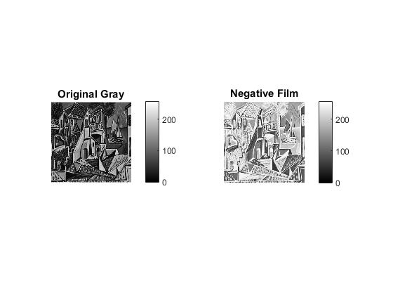

Figure05: The negative film of original grayscale image.

***Some more image processing on different images:***

**************Jupiter Great Red Spot****************



